
COMSATS University Islamabad (CUI)

Project Proposal
for
OVULITE

Version 1.0
By
Eman Malik CIIT/SP23-BDS-012/ISB
Inshal Zafar CIIT/SP23-BDS-021/ISB

Supervisor
Dr. Nusrat Shaheen

Bachelor of Science in Data Science (2023-2027)

Table of Contents
Abstract 2
1. Introduction 2
2. Problem Statement 3
3. Problem Solution/Objectives of the Proposed System 3
3.1 Objectives 4
4. Related System Analysis/Literature Review 4
5. Vision Statement 5
6. Scope 5
7. Modules 6
7.1 Module 1: Pregnancy Success Prediction Engine 6
7.2 Module 2: Abortion Risk Alert System 6
7.3 Module 3: AI Embryo Grading (Image + Metadata Fusion) 6
7.4 Module 4: Embryo–Recipient Matching Assistant 7
7.5 Module 5: Donor & Sire Performance Analytics 7
7.6 Module 6: Protocol Effectiveness Analysis 7
7.7 Module 7: Technician Performance Dashboard 7
7.8 Module 8: Reproductive Intelligence Dashboard 7
8. System Limitations/Constraints 7
9. Data Gathering Approach 8
10. Tools and Technologies 8
11. Project Stakeholders and Roles 9
12. Module based Work Division 10
13. References 10
14. Plagiarism Report 11

Project Category: (Select all the major domains of proposed project)
A-Desktop Application/Information System B-Web Application/Web Application based Information System C-Problem Solving and Artificial Intelligence D-Simulation and Modeling E-Smartphone Application
F-Smartphone Game G-Networks H-Image Processing
Other (specify category): IVF

Abstract
The rapid expansion of IVF and embryo transfer (ET) in Pakistan’s cattle industry has exposed critical challenges in reproductive decision-making, where technicians and embryologists still rely on subjective visual assessment and manual judgment. This results in inconsistent pregnancy outcomes, misuse of embryos, and significant economic losses for farms adopting assisted reproductive technologies. The proposed system aims to resolve these challenges by enabling objective, data-driven prediction of pregnancy success, early identification of abortion risk, and improved embryo-recipient matching to optimize reproductive efficiency. A major grey area in current practice is the absence of an integrated AI platform that analyzes existing embryology, donor, recipient, technician, and hormonal data to support accurate on-ground decisions. Ovulite – AI-Driven Embryo Success Prediction and Reproductive Intelligence System for Cattle seeks to overcome this gap by building machine-learning models for pregnancy prediction, abortion risk assessment, and AI-based embryo grading using image-metadata fusion. The system further aims to provide reproductive analytics, donor–sire performance insights, and technician effectiveness reports, allowing farms to improve outcomes using the data they already collect. Ultimately, this project will enhance overall reproductive success, reduce embryo wastage, and support Pakistan’s transition toward precision livestock reproduction.

Introduction
The purpose of this project proposal is to outline the design and development of Ovulite – AI-Driven Embryo Success Prediction and Reproductive Intelligence System for Cattle, a data-centric solution aimed at improving the accuracy and efficiency of assisted reproductive processes in livestock. With the increasing adoption of IVF (In-Vitro Fertilization) and ET (Embryo Transfer) technologies in Pakistan, farms and embryology labs are generating large amounts of valuable reproductive data that remain underutilized due to the absence of intelligent analytical tools. Current decision-making practices rely heavily on manual assessment of embryo quality, recipient suitability, hormonal status, and technician skill, which often results in inconsistent reproductive outcomes. Variability in CL size, blood flow, progesterone levels, embryo day, and recipient physiology further complicates the process, making success prediction difficult without systematic data-driven support. Additionally, farms lack structured analytics to evaluate the performance of donors, sires, embryos, recipients, media batches, or technicians over time, leading to repeated inefficiencies and increased operational costs. Technological advancements in machine learning, image analysis, and predictive modeling offer opportunities to transform this domain through automated embryo grading, pregnancy prediction, and abortion risk assessment. Ovulite aims to integrate these modern AI-based capabilities into a unified system that leverages existing field and laboratory data to support better reproductive decisions. The system intends to provide embryologists, veterinarians, and farm managers with actionable insights derived from CL measurements, blood flow scores, P4 levels, embryo characteristics, and historical ET outcomes. By bridging the gap between practical livestock operations and advanced computational methods, Ovulite aspires to introduce precision reproduction into Pakistan’s cattle industry. This proposal details the problem, objectives, scope, methodologies, and expected contribution of the system in enhancing the reliability of cattle IVF and ET programs.

Problem Statement
The current reproductive management practices in Pakistan’s cattle IVF and embryo transfer industry rely heavily on subjective assessment, intuition, and manual interpretation of biological indicators. Embryologists and field veterinarians often evaluate embryo grade, recipient suitability, CL size, blood flow, and hormonal profiles based on visual judgment rather than standardized, data-driven criteria. This leads to inconsistent pregnancy outcomes, higher rates of early embryonic loss, and inefficient use of expensive donor-derived embryos. Furthermore, IVF labs lack analytical tools to correlate embryology parameters—such as embryo day, media type, oocyte yield, and technician involvement—with pregnancy success, making it difficult to identify performance bottlenecks. Recipient selection remains a trial-and-error process because farms do not have systems that combine CL size, progesterone levels, blood flow, and physiological history to calculate suitability or predict embryo acceptance. The absence of automated monitoring and prediction mechanisms contributes to avoidable embryo wastage and financial losses, especially when frozen embryos or high-value donor genetics are used. Moreover, farms have no structured way of tracking abortion risk using early hormonal patterns, blood-flow changes, or falling P4 trends, resulting in late detection of failing pregnancies. This lack of predictive intelligence prevents timely interventions and increases overall reproductive failure rates.
Despite farms collecting substantial data during OPU, IVF, ET, and pregnancy checks, there is no integrated platform that analyzes these datapoints holistically to guide technicians and managers. As a result, opportunities for optimizing donor–sire pairings, recipient selection, embryo grading consistency, and technician performance remain unmet. The development of an AI-powered system that leverages existing data to provide accurate predictions, actionable insights, and reproductive intelligence is therefore essential to improving success rates, reducing losses, and enabling precision livestock reproduction.

Problem Solution/Objectives of the Proposed System
The proposed system, Ovulite – AI-Driven Embryo Success Prediction and Reproductive Intelligence System for Cattle, is designed to introduce objective, data-driven decision-making into Pakistan’s cattle IVF and embryo transfer workflow. By leveraging the dataset already collected during OPU, IVF, ET, and pregnancy monitoring, the system replaces subjective judgment with quantifiable, reproducible, and AI-supported assessments. The core of the solution is a machine-learning-based pregnancy prediction model that uses CL size, blood flow, progesterone level, embryo day, embryo grade, donor-sire metadata, and technician history to estimate the likelihood of successful conception. This prediction empowers veterinarians and embryologists to prioritize high-probability transfers and avoid wasting valuable embryos on unsuitable recipients. Ovulite also includes an abortion risk prediction module that analyzes early hormonal patterns, CL regression, weight changes, and blood-flow signals to alert users about high-risk pregnancies.
The system further addresses embryo-quality inconsistencies through an AI-backed embryo grading model using image–metadata fusion that enhances grading accuracy and reduces inter-technician variability. An embryo–recipient matching engine optimizes the allocation of embryos by recommending top three recipients based on physiological, hormonal, and historical ET factors. In addition, Ovulite performs donor and sire performance analytics to help farms identify top genetic combinations and plan more effective breeding strategies. Technician performance evaluation enables IVF labs to monitor operator-level variation and improve SOPs through feedback loops. The system also analyzes protocol effectiveness, allowing users to compare outcomes of fresh versus frozen embryos, ET timing, or synchronization protocols.
By centralizing all reproductive data into a single unified platform, Ovulite transforms scattered farm records into actionable intelligence. It introduces predictive analytics, early warning alerts, and performance dashboards that significantly enhance reproductive efficiency. In doing so, the system aims to reduce embryo losses, improve conception rates, support timely interventions, and provide a repeatable methodology for high-quality ET operations. Ultimately, Ovulite enables precision livestock reproduction through modern artificial intelligence and systematic reproductive analytics.

Objectives
BO-1: Develop a machine-learning model to predict embryo pregnancy success using CL size, blood flow, P4, embryo metadata, and technician input.
BO-2: Build an abortion risk alert system to identify pregnancies prone to early loss based on hormonal and physiological indicators.
BO-3: Implement an AI-based embryo grading system using image–metadata fusion to improve grading accuracy and reduce technician subjectivity.
BO-4: Design an embryo–recipient matching engine to recommend the most suitable recipients for each embryo.
BO-5: Analyze synchronization protocol effectiveness (e.g., Conventional vs Sexed embryos, CIDR, PGF2α, GnRH) to support evidence-based IVF and ET decision-making.
BO-6: Integrate all data sources into a unified reproductive intelligence dashboard for farms and IVF labs.
BO-7: Reduce embryo wastage and improve overall pregnancy success through actionable, data-driven insights.

Related System Analysis/Literature Review
Several digital and AI-enabled livestock solutions exist globally, but none provide an integrated embryo-level reproductive intelligence system specifically designed around Pakistan’s cattle IVF and ET workflows. EmGenysis is an embryo monitoring and management platform offering digital embryo records and donor tracking; however, it lacks AI-based pregnancy prediction, abortion risk alerts, and recipient suitability analysis, making it insufficient for data-driven ET decisions. Folio3 AI Livestock Management provides herd monitoring, disease alerts, and vision-based animal identification, but does not support IVF-related analytics, embryo grading, or ET success modeling. EmbryoPlus, a commercial bovine reproduction service, offers advanced IVF services and donor management but does not provide farm-level predictive models or AI-driven embryo–recipient matching based on physiological and hormonal data. Taurus Herd Health focuses on herd fertility monitoring and insemination tracking, yet it does not incorporate embryo image analysis, donor–sire matrix optimization, or technician performance analytics.
These limitations highlight the global gap in integrated, AI-supported embryo-level reproductive intelligence. Ovulite addresses this gap by merging embryo-quality assessment, pregnancy prediction, abortion-risk modeling, recipient suitability scoring, and donor/sire analytics into one unified reproductive intelligence system powered by machine learning and image fusion models.

Table 1 Related System Analysis with proposed project solution
Application Name | Weakness | Proposed Project Solution
Folio3 AI Livestock Management | Focuses on herd health and monitoring, not IVF/ET-specific reproductive analytics or embryo-quality evaluation. | Ovulite integrates embryo grading (image + metadata fusion), donor–recipient analytics, and ET-focused predictive models.
EmbryoPlus | Provides IVF services but lacks predictive intelligence, in-lab embryo viability scoring, and recipient suitability modeling. | Ovulite adds AI embryo grading, CL/P4-based suitability scoring, technician analytics, and donor–sire sweet spot analysis.
Taurus Herd Health | Tracks fertility cycles but does not handle embryo images, IVF workflows, ET success prediction, or donor–sire matrix. | Ovulite extends functionality with advanced embryo analytics, ML prediction models, and reproductive intelligence dashboards.
EmGenysis | Offers embryo records but no AI pregnancy prediction, abortion risk assessment, or embryo–recipient matching. | Ovulite provides ML-based pregnancy prediction, abortion alerts, and AI-driven embryo matching to improve ET success rates.

Vision Statement
For cattle farms, IVF laboratories, embryologists, and livestock reproduction specialists Who require accurate, data-driven predictions to improve embryo transfer success and reduce reproductive losses The Ovulite – AI-Driven Embryo Success Prediction and Reproductive Intelligence System for Cattle Is an integrated reproductive analytics and decision-support platform That uses machine learning, embryo image analysis, hormonal indicators, and historical ET data to predict pregnancy outcomes, assess abortion risk, grade embryos with AI, and recommend optimal embryo–recipient matches Unlike existing herd management tools, manual embryo grading, or subjective technician assessments Our product offers a unified embryo-to-pregnancy intelligence system that delivers precise predictions, real-time reproductive alerts, donor–sire performance insights, and operator analytics — all derived from the farm’s existing IVF and ET datasets.

Scope
The scope of Ovulite – AI-Driven Embryo Success Prediction and Reproductive Intelligence System for Cattle encompasses the development of a unified decision-support platform that analyzes data generated throughout the IVF–ET–pregnancy cycle. The system will process donor, sire, embryo, recipient, technician, hormonal, and pregnancy outcome data already collected by farms and IVF laboratories to deliver actionable reproductive intelligence. Key functionalities include machine-learning-based pregnancy success prediction, abortion risk assessment, AI-powered embryo grading using image–metadata fusion, and an optimized embryo–recipient matching assistant. Ovulite will generate reproductive analytics, such as donor performance ranking, sire compatibility matrices, protocol effectiveness, embryo day/stage success trends, and technician performance insights to support evidence-based management decisions. The system will visualize CL size, blood flow, progesterone levels, embryo quality, and ET outcomes to help identify sweet spots and failure patterns in existing reproductive workflows.
Additionally, Ovulite will incorporate a dashboard for monitoring reproductive KPIs, including OPU-to-pregnancy funnel analytics, embryo batch health, and embryo wastage patterns. The platform will provide a structured interface for embryologists to enter embryo metadata and images, and for veterinarians to update recipient profiles and pregnancy outcomes. The solution does not include real-time sensor integration, genomic analysis, drone imaging, environmental prediction, or automated physiological monitoring, as these are beyond the dataset and resources available in the current project. It also excludes financial modules unrelated to reproduction, such as full herd management, milk yield tracking, or feedlot operations.
The project will deliver a functional prototype containing core predictive models, visual dashboards, and user interfaces required for practical use by IVF labs and farm managers. Ovulite will be deployed as a web-based application and may include a supportive chatbot for explanation and guidance. By defining clear functional boundaries, the project ensures feasibility within available data, academic timeline, and computational resources while still offering high-impact AI-driven reproductive intelligence for cattle.

Modules
The proposed system consists of several core modules that collectively deliver AI-driven reproductive intelligence for cattle. Each module is designed to transform raw IVF–ET–pregnancy data into meaningful predictions, alerts, and analytics. The system is divided into functional components that cover embryo assessment, pregnancy prediction, abortion risk identification, donor/sire analytics, protocol effectiveness, and operator performance evaluation. The following modules and their features define the precise boundaries of the Ovulite system.

Module 1: Pregnancy Success Prediction Engine
FE-1: Predict pregnancy outcome using CL size, blood flow score, P4 level, embryo metadata, technician, and protocol.
FE-2: Display prediction probability as percentage and RAG (Red–Amber–Green) score.
FE-3: Provide SHAP-based explanatory factors for each prediction.
FE-4: Compare prediction against similar historical cases for validation.

Module 2: Log- in System
FE-1: Secure user login ensures only authorized individuals can access the system.
FE-2: Access is controlled through role-based permissions, allowing users to view and manage features according to their assigned roles.
FE-3: Active session management maintains user security and ensures smooth, uninterrupted system usage.
FE-4: Secure logout functionality protects user data by safely ending sessions when access is no longer needed.

Module 3: AI Embryo Grading (Image + Metadata Fusion)
FE-1: Upload embryo images (Day 6/7/8).
FE-2: Extract image-based features using a CNN (e.g., ResNet).
FE-3: Combine image features with metadata (day, donor, media, embryo stage).
FE-4: Predict embryo grade (1/2/3) and viability score.
FE-5: Display visual heatmaps showing embryo regions contributing to grade.

Module 4: LAB QC - Batch and Drift Monitor

FE-1: Monitor laboratory performance trends using media type, technician, embryo stage/day, and batch grouping.
FE-2: Apply unsupervised anomaly detection (Isolation Forest / control charts) to detect deviations from baseline performance.
FE-3: Identify media-related underperformance or technician performance drift.
FE-4: Flag abnormal weekly/monthly batches for investigation.
FE-5: Provide alert-based notifications within the dashboard for early quality control intervention.

Module 5: Protocol Effectiveness Analysis
FE-1: Compare outcomes for conventional vs sexed embryos.
FE-2: Evaluate synchronization protocols (CIDR, PGF2α, GnRH).
FE-3: Analyze technician × protocol interactions.
FE-4: Provide protocol success dashboards with pregnancy % and abortion %.

Module 6: Reproductive Intelligence Dashboard
FE-1: Display overall pregnancy success rate with month-wise trend analysis.
FE-2: Present abortion rates categorized by trimester.
FE-3: Show recent AI embryo grading outputs and ET prediction results.
FE-4: Display LabQC alerts and anomaly notifications.
FE-5: Provide unified KPI visualization including ET counts, active pregnancies, and donor leaderboard summaries.

System Limitations/Constraints
LI-1: The system is limited to the dataset currently available, which includes donor, sire, embryo, recipient, hormonal, technician, and pregnancy outcome information; it cannot train models requiring genomics, environmental data, feed intake, or sensor-based physiological measurements.
LI-2: Ovulite does not integrate real-time IoT devices, automated ultrasound imaging, or continuous hormonal monitoring, as such data is not accessible within the scope of this project.
LI-3: The AI embryo grading module depends on the quality and quantity of embryo images provided; inconsistent lighting, focus, or image resolution may affect grading accuracy.
LI-4: Machine learning predictions will be constrained by the size and diversity of the dataset, and may not generalize perfectly across all breeds, technicians, or farms without further data expansion.
LI-5: The system is designed for cattle IVF and ET workflows and does not extend to full herd management such as feeding schedules, milk yield tracking, disease monitoring, or financial reporting.
LI-6: Ovulite is a decision-support system and does not replace professional veterinary or embryology expertise; its predictions must be interpreted by qualified personnel.
LI-7: The prototype will be a web-based application subject to internet availability, bandwidth constraints, and device compatibility limitations on rural farms with weak connectivity.

Data Gathering Approach
Data for this project is being gathered from the IVF laboratory at DayZee Farms, which has been actively performing OPU, IVF, and ET procedures for over two years. The farm maintains detailed logs of donors, embryos, recipients, hormone values, technician information, and pregnancy outcomes, which serve as the primary dataset for Ovulite’s predictive models. Additional insights are collected through brief interviews and discussions with embryologists and veterinarians to understand workflow requirements and decision-making patterns. This ensures that the system is built on authentic, real-world reproductive data and operational practices.

Tools and Technologies
Table 2: Tools and Technologies for Proposed Project
Tools and Technologies | Tools and Technologies | Version | Rationale
 | Frontend Development
 | Next.js | 13 (Latest) | A React-based framework used for building server-side rendered applications. Provides SEO optimization and faster page load times, ideal for the web app.
 | HTML5 | Latest | Core markup language used to structure content on the web. Essential for building web pages with semantic elements.
 | CSS3 | Latest | Styling language used to create the layout, design, and responsive structure of web pages, ensuring compatibility across different devices and screen sizes.
 | JavaScript | ES6 (Latest) | A scripting language used to add interactivity to websites. Handles frontend logic, DOM manipulation, and API requests.
 | Backend Development
 | Node.js | 18 (LTS) | JavaScript runtime environment for server-side scripting. Allows for building full-stack applications using JavaScript.
 | Express.js | 4.17.1 | A web framework for Node.js used for building RESTful APIs and handling routing and middleware in backend development.
 | Flask | 2.0.2 | A Python-based micro-framework used to build lightweight REST APIs. Works well for integrating machine learning models into the backend.
 | Machine Learning
 | TensorFlow | 2.8 | An open-source machine learning library used for building neural networks, such as for pregnancy prediction and embryo grading.
 | Keras | 2.8 | A high-level API for building and training deep learning models. Simplifies model development, particularly for image-based tasks.
 | Scikit-learn | 1.0.2 | Python library is used for traditional machine learning algorithms such as classification, regression, and clustering.
 | PyTorch | 1.11 | Deep learning framework for training complex neural networks. Primarily used for image analysis tasks like embryo grading.
 | Pandas | 1.4.2 | Python library is used for data manipulation and analysis. Essential for preprocessing and cleaning data before feeding it into machine learning models.
 | NumPy | 1.22.4 | Core library for numerical computing. Handles arrays and matrices, essential for working with data in machine learning models.
 | Database
 | MySQL | 8.0 | An open-source relational database management system. Perfect for storing structured data such as embryos, donors, recipients, and pregnancy outcomes.
 | MongoDB | 5.0 | A NoSQL database used for storing unstructured or semi-structured data. Good for handling flexible schemas, but might not be necessary for this project.
 | Image Processing
 | OpenCV | 4.5.5 | Open-source computer vision library. Used for analyzing and processing embryo images for feature extraction, helping with tasks like grading embryo quality.
 | Testing and debugging
 | Postman | 9.1 | A platform for testing APIs. Allows easy creation and testing of HTTP requests and responses. Essential for ensuring API functionality during development.
 | UI/UX Design Tools
 | Figma | Free Plan | A collaborative design tool used for creating wireframes, prototypes, and interactive mockups. Ideal for frontend design and client feedback.

Project Stakeholders and Roles
Table 3 Project Stakeholders for Proposed Project
Stakeholders | Responsibilities
Project Sponsor:  DayZee Farms | Provides project funding, access to farm data, equipment, and technical resources. Owns all rights to the final product.
Stakeholder | Provides academic supervision, evaluation, and project guidance within the FYP framework.
Farm Manager | Shares operational data, validates system outputs, and provides feedback for real-world usability.
Veterinarian | Supplies embryo transfer (ET), pregnancy, and abortion records; ensures accuracy of health-related data.
Student Developers:  Eman Malik  Inshal Zafar | Designs, develops, and implements the data collection and analysis system; manages database and dashboards.
Project Supervisor:  Mam Nusrat Shaheen | Guides technical development, reviews documentation, and ensures academic and professional standards.
Final Year Project Committee | Evaluates project progress, implementation, and final outcomes for academic grading and compliance.

Module based Work Division
Table 4 Team Member Work Division for Proposed Project

Student Name | Student Registration Number | Responsibility/ Module / Feature
Eman Malik | SP23-BDS-012 | Module 1: Embryo Success Prediction – Development of machine learning models to predict pregnancy success, integration of prediction logic into the backend.
 |  | Module 2: Data Visualization & Analytics – Creation of visual dashboards to display predictive analytics, embryo data trends, and pregnancy success insights.
 |  | Module 3: User Interface & Experience Design – Designing and testing the frontend layout, optimizing the user experience, and ensuring ease of navigation for farm staff and medical professionals.
Inshal Zafar | SP23-BDS-021 | Module 4: Data Management & Database Integration – Design and implementation of the database schema, ensuring smooth data storage for embryos, recipients, and pregnancy outcomes.
 |  | Module 5: Machine Learning & Model Integration – Training machine learning models for embryo grading, integrating models into the system, and fine-tuning prediction accuracy.
 |  | Module 6: System Testing & Deployment – Conducting testing phases, including unit testing and debugging, followed by deploying the application on the cloud platform.

WBS and GANTT CHART

Work Based Structure(WBS)
The Work Breakdown Structure (WBS) for the Ovulite project is organized into three hierarchical levels to ensure clear scope definition, effective planning, and controlled execution.
Level 1 – Major Phases
Level 1 represents the major phases of the software development lifecycle. These phases define the overall structure of the project and group related activities at a high level.
The major phases of the Ovulite project are:
- Requirements & Planning
- System Design
- Data Preparation & Machine Learning
- Application Development
- Testing & Validation
- Deployment & Documentation
Level 2 – Sub-Activities
Level 2 decomposes each major phase into logical sub-activities that describe the key functional areas within that phase. These activities represent significant tasks required to complete each phase.
Examples include:
- Requirements analysis and documentation within Requirements & Planning
- Architecture, database, and UI design within System Design
- Data preprocessing and model development within Data Preparation & Machine Learning
- Module-wise implementation within Application Development

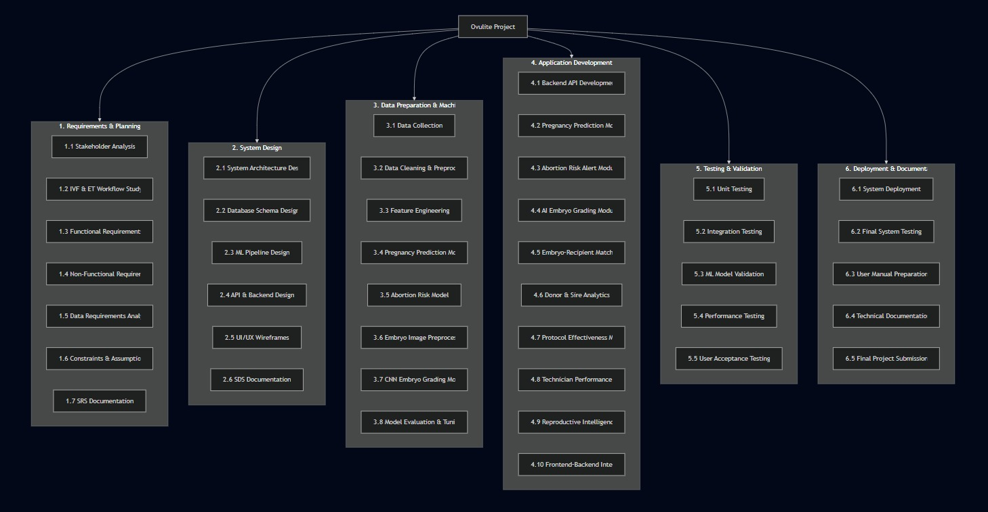

GANTT Chart

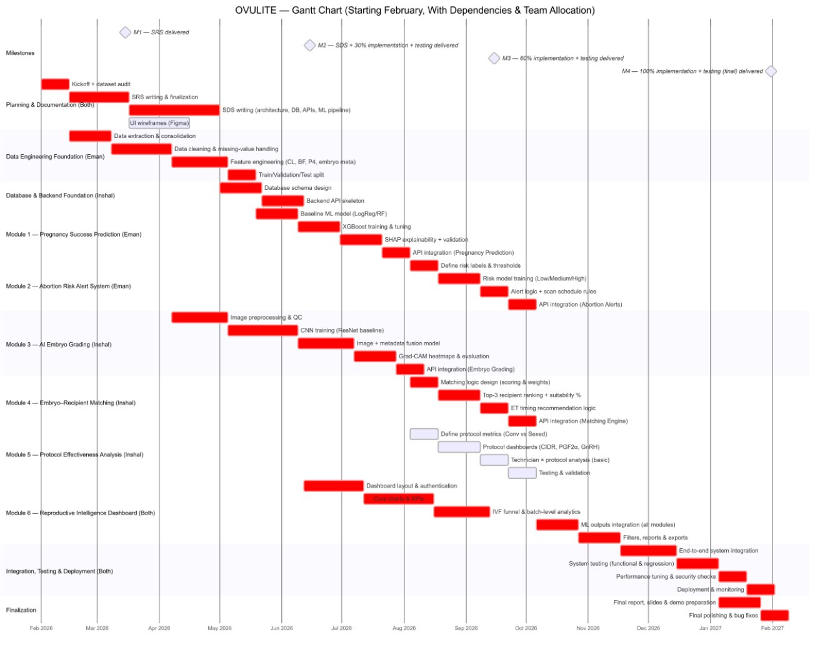

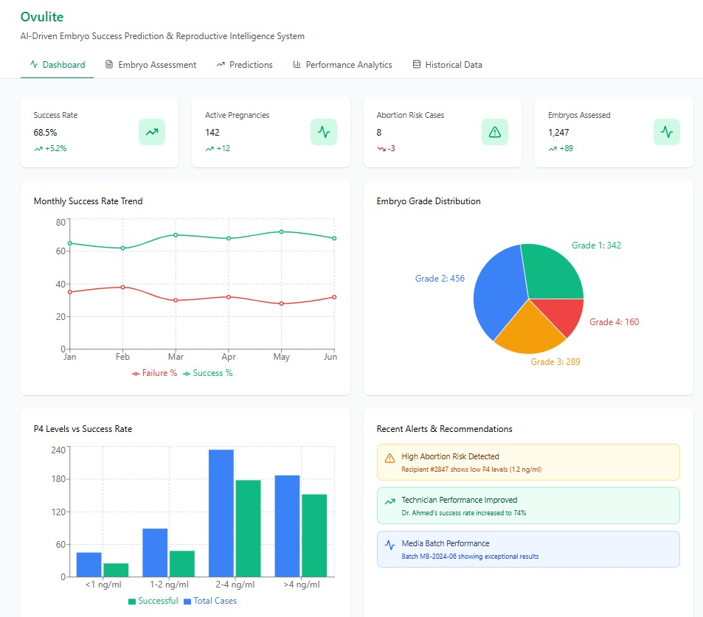
Mockups:

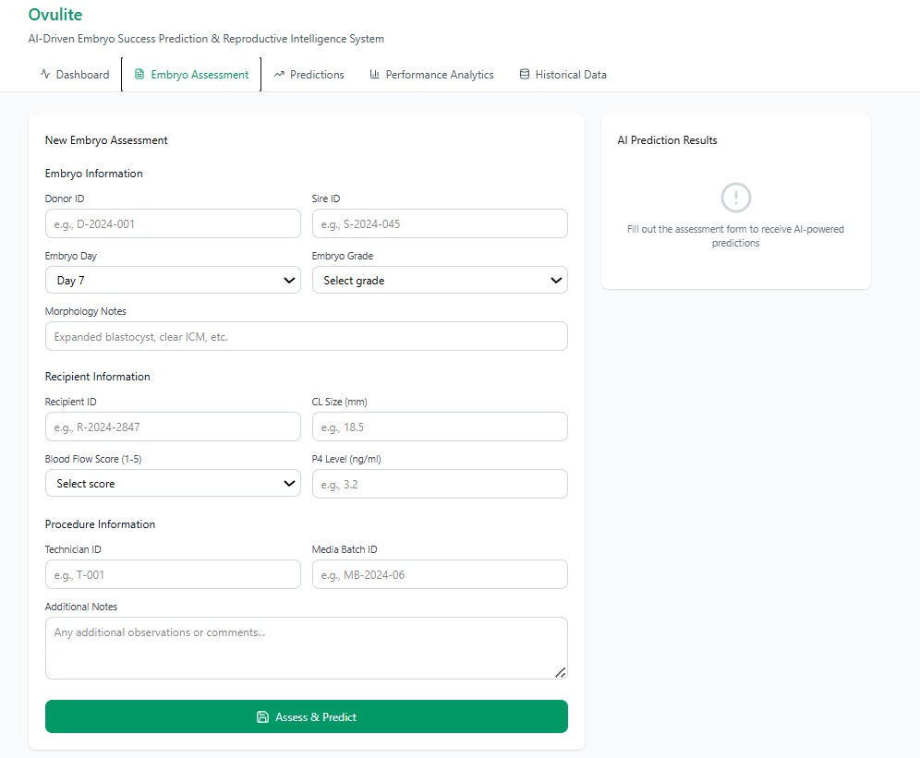

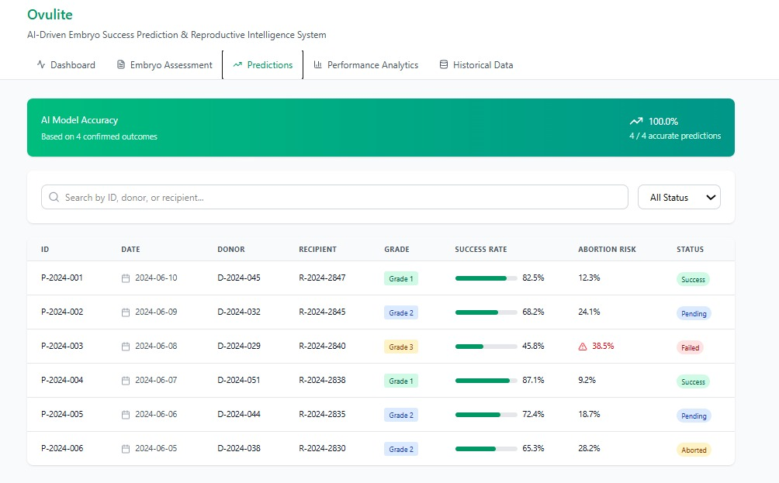
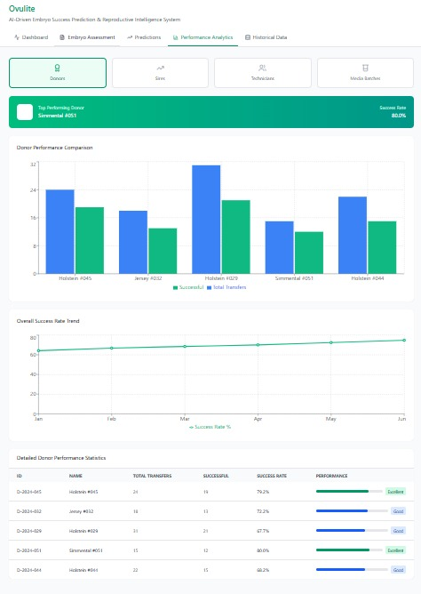
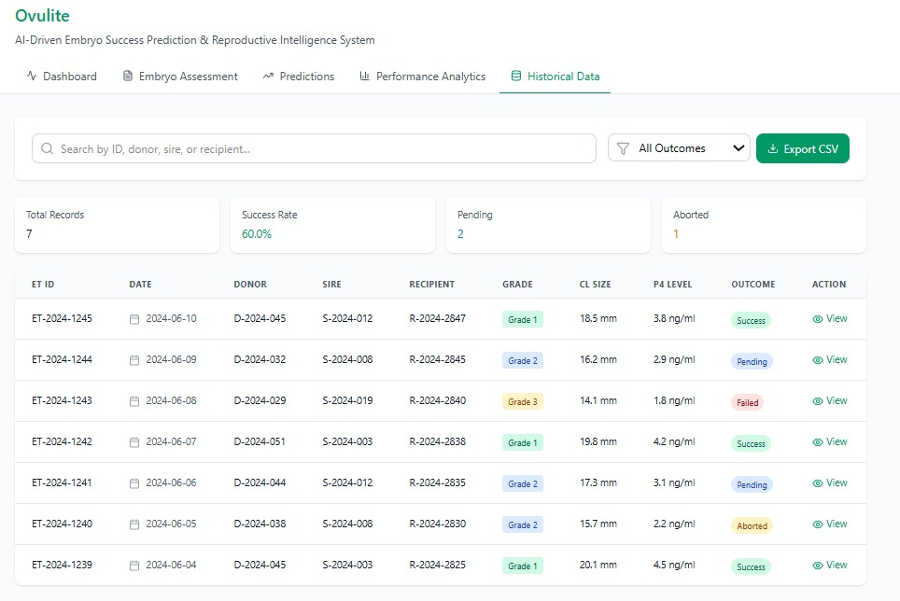

References
[1] R. J. Mapletoft, G. A. Bó, and P. S. Baruselli, “Control of ovarian function for assisted reproductive technologies in cattle,” Animal Reproduction, vol. 15, suppl. 1, pp. 54–69, 2018.
(Foundational reference for IVF, ET, and reproductive workflows in cattle.)
[2] G. Pugliesi et al., “Use of Doppler ultrasonography for evaluation of corpus luteum function and pregnancy in cattle,” Theriogenology, vol. 82, no. 1, pp. 77–86, 2014.
(Directly supports CL size, blood flow, and pregnancy prediction modules.)
[3] P. Lonergan and T. Fair, “The role of progesterone in embryo development and pregnancy establishment in cattle,” Theriogenology, vol. 86, no. 1, pp. 210–216, 2016.
(Key reference for P4-based pregnancy success and abortion risk.)
[4] J. F. Hasler, “Forty years of embryo transfer in cattle: A review,” Theriogenology, vol. 81, no. 1, pp. 152–169, 2014.
(Supports embryo transfer success factors and real-world IVF limitations.)
[5] T. Chen and C. Guestrin, “XGBoost: A scalable tree boosting system,” in Proc. 22nd ACM SIGKDD Int. Conf. Knowledge Discovery and Data Mining, 2016, pp. 785–794.
(Supports ML-based pregnancy prediction model.)
[6] K. He, X. Zhang, S. Ren, and J. Sun, “Deep residual learning for image recognition,” in Proc. IEEE Conf. Computer Vision and Pattern Recognition (CVPR), 2016, pp. 770–778.
(Supports CNN-based embryo image grading.)

Plagiarism Report




